Network Layers
- Application Layer (Layer 7)
  - The layer that users / applications interact with, it generates HTTP requests, Email requests (SMTP) or file transfers etc..
  - Its job is to create the request into a valid format
  - Security: This layer is where WAF sits it scans the data in this layer before it is packed and sent across the network
  - Examples: HTTP, HTTPS, SMTP (Email), SSH
- Presentation Layer (Layer 6)
  - This layer formats data so that receiver could understand it
    - Example: 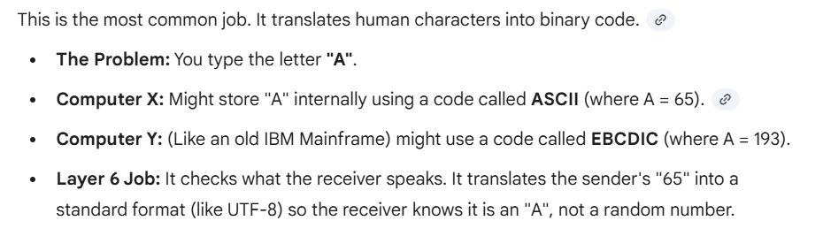
  - Security: This layer also handles encryption of Data if HTTPS is being used
  - Examples: SSL/TLS (Encryption), JPEG, ASCII, JSON formatting
- Session Layer (Layer 5)
  - The "Manager." It establishes, maintains, and terminates connections between applications. It keeps different data streams separate (so your YouTube tab doesn't mix with your Email tab)
  - Example: APIs, Sockets
- Transport Layer (Layer 4)
  - The "Postman." It ensures data arrives reliably and completely. It breaks large data into small "segments." It uses Ports to direct traffic to the right service (Web vs. Email)
  - Security: in terms of security Standard network Firewalls sit here to block port 22 or 88 for example
- Network Layer (Layer 3)
  - The "Navigator." It handles Routing. It adds IP Addresses to packets to figure out the best path across the internet to reach the destination
  - Security: Routers and Network Firewalls work here (blocking specific IP addresses)
  - Examples: IP Addresses (IPv4, IPv6), Routers, ICMP (Ping)
- Data Link Layer (Layer 2)
  - The "Local Delivery." It moves data between devices on the same network (like your laptop to your Wi-Fi router). It uses MAC Addresses (hardware IDs)
  - Example: MAC Addresses
- Physical Layer (Layer 1)
  - The "Raw Physics." It converts binary data (1s and 0s) into electrical signals, light pulses, or radio waves
  - Example: Ethernet cables, Fiber Optics
Why is WAF at layer 7 example
Attacker tries to use SQL injection